**K L HYDERABAD**

**FRESHMAN ENGINEERING DEPARTMENT**

**A Project-Based Lab Report**

**On**

**STUDENT FEEDBACK FORM**

**SUBMITTED BY:**

I.D NUMBER NAME

2110030359 BOPPELLA CHIHNITA REDDY

**UNDER THE ESTEEMED GUIDANCE OF**

**Dr. Mahesh Babu Arrama**

**Associate Professor**



**KONERU LAKSHMAIAH EDUCATION FOUNDATION**

(Deemed to be University)

Moinabad Road, Aziz Nagar, Hyderabad - 500075

**DEPARTMENT OF BASIC ENGINEERING SCIENCES**



**CERTIFICATE**

This is to certify that the project-based laboratory report entitled “STUDENT FEEDBACK FORM” submitted by Ms**. BOPPELLA CHIHNITA REDDY** bearing Regd. No. 2110030359 to the **Department of Basic Engineering Sciences, KL University** in partial fulfillment of the requirements for the completion of a project in “Computational Thinking For Object-Oriented Programming-21CS1203”course in I B Tech II Semester, is a bonafide record of the work carried out by him/her under my supervision during the academic year 2020-21.

PROJECT SUPERVISOR HEAD OF THE DEPARTMENT

Dr. Mahesh Babu Arrama Dr. G. REKHA

**ACKNOWLEDGEMENTS**

It is great pleasure for me to express my gratitude to our honorable President **Sri. Koneru Satyanarayana**, for giving the opportunity and platform with facilities in accomplishing the project-based laboratory report.

I express my sincere gratitude to our Principal **Dr. L. Koteswara Rao** for his administration of our academic growth.

I express sincere gratitude to our Coordinators **Dr. G.Rekha** and HOD-BES-1 **Dr. G. Rekha** for their leadership and constant motivation provided in the successful completion of our academic semester. I record it as my privilege to deeply thank you for providing us with the efficient faculty and facilities to make our ideas into reality.

I express my sincere thanks to our project supervisor **Dr. Mahesh Babu Arram** for her novel association of ideas, encouragement, appreciation, and intellectual zeal which motivated us to venture into this project successfully.

Finally, it is pleased to acknowledge the indebtedness to all those who devoted themselves directly or indirectly to making this project report success.

Name: BOPPELLA CHIHNITA REDDY

Regd . No: 2110030359

**ABSTRACT**

This project is about the STUDENT FEEDBACK FORM in the GUI application.

The main of the project is to create a GUI (GRAPHICAL USER INTERFACE) application. The Principal of Delhi Public School wants to know about his faculty’s knowledge of their respective subjects, so he has asked you to develop a GUI-based program that should contain sections, the faculty list for that particular section, and the student’s feedback about that faculty. Store this data in a separate file such that each section has its separate file from which he can retrieve the data anytime.

**INDEX**

|  |  |  |
| --- | --- | --- |
| **S.NO** | **TITLE** | **PAGE NO** |
| 1 | Introduction | 6 |
| 2 | Aim of the Project | 7 |
| 2.1 | Advantages & Disadvantages | 7 |
| 3 | Software & Hardware Details | 8 |
| 4 | Implementation | 9-17 |
| 5 | Outputs/ScreenShots | 18-19 |
| 6 | Conclusion | 20 |

**INTRODUCTION**

The main aim of the project is to create a GUI (Graphical User Interface) to make it easy for the customers to select their interested car. GUI is the interface where images are used to represent different choices. The choices are designed as per the requirement of the end-user applications. Now, in this project we will include combo-boxes, text fields, buttons, labels, and j-frame.

We have to enter the student id number and we have to select the section and then the faculty name and then the feedback button. Now we submit then it will get saved in the files

We have to write the final output in files using the file Writer concept. We can create our design in a very attractive manner by using graphical user interfaces.

**AIM**

The main of this project is to create the details of the car models which will be helpful to the customers when they visit the showrooms.

**Advantages:-**

* GUI is very attractive and multi-colored.
* Programmer or user need not have to understand the working of the computer system.
* Userser should be able to use the application immediately, find the functionality they want, and not get frustrated.
* Users need not know any programming languages.

**Disadvantages:-**

* Java mainly works on storage and does not focus on the backup of data.
* GUI uses more computer memory as the main is to make it user-friendly and not resource-optimized.
* GUI becomes more complex if the user needs to communicate with the computer directly.
* Making changes to menus is not simple, or even reliable.

**SYSTEM REQUIREMENTS**

* **SOFTWARE REQUIREMENTS:**

The major software requirements of the project are as follows:

Language: JAVA

Operating system**:** Windows XP or later.

Tools: Eclipse IDE

* **HARDWARE REQUIREMENTS:**

The hardware requirements that map towards the software are as follows:

RAM: 16 GB

Processor: i7

**IMPLEMENTATION**

**package** p1;

**import** java.awt.EventQueue;

**import** javax.swing.JFrame;

**import** javax.swing.JLabel;

**import** javax.swing.JOptionPane;

**import** java.awt.Color;

**import** java.awt.Font;

**import** javax.swing.JButton;

**import** javax.swing.JComboBox;

**import** javax.swing.DefaultComboBoxModel;

**import** javax.swing.JRadioButton;

**import** java.awt.event.ActionListener;

**import** java.io.FileWriter;

**import** java.io.BufferedWriter;

**import** java.io.IOException;

**import** java.awt.event.ActionEvent;

**import** javax.swing.JTextField;

**import** javax.swing.ButtonGroup;

**import** javax.swing.AbstractAction;

**import** javax.swing.Action;

**public** **class** STUDENT {

**private** JFrame frame;

**private** JTextField textField;

**private** **final** ButtonGroup buttonGroup = **new** ButtonGroup();

**private** **final** ButtonGroup buttonGroup_1 = **new** ButtonGroup();

**private** **final** Action action = **new** SwingAction();

/**

* Launch the application.

*/

**public** **static** **void** main(String[] args) {

EventQueue.*invokeLater*(**new** Runnable() {

**public** **void** run() {

**try** {

STUDENT window = **new** STUDENT();

window.frame.setVisible(**true**);

} **catch** (Exception e) {

e.printStackTrace();

}

}

});

}

/**

* Create the application.

*/

**public** STUDENT() {

initialize();

}

/**

* Initialize the contents of the frame.

*/

**private** **void** initialize() {

frame = **new** JFrame();

frame.getContentPane().setBackground(Color.***CYAN***);

frame.setBounds(100, 100, 977, 592);

frame.setDefaultCloseOperation(JFrame.***EXIT_ON_CLOSE***);

frame.getContentPane().setLayout(**null**);

JLabel lblStudentData = **new** JLabel("STUDENT DATA");

lblStudentData.setForeground(Color.***BLACK***);

lblStudentData.setFont(**new** Font("Times New Roman", Font.***BOLD***, 50));

lblStudentData.setBounds(205, 11, 475, 78);

frame.getContentPane().add(lblStudentData);

JLabel lblSectionList = **new** JLabel("SECTION LIST");

lblSectionList.setFont(**new** Font("Times New Roman", Font.***BOLD***, 21));

lblSectionList.setBounds(37, 193, 200, 47);

frame.getContentPane().add(lblSectionList);

JLabel lblFaculty = **new** JLabel("FACULTY ");

lblFaculty.setFont(**new** Font("Times New Roman", Font.***BOLD***, 21));

lblFaculty.setBounds(37, 268, 200, 47);

frame.getContentPane().add(lblFaculty);

JLabel lblStudentFeedback = **new** JLabel("STUDENT FEEDBACK");

lblStudentFeedback.setFont(**new** Font("Times New Roman", Font.***BOLD***, 21));

lblStudentFeedback.setBounds(37, 347, 225, 47);

frame.getContentPane().add(lblStudentFeedback);

JComboBox comboBox = **new** JComboBox();

comboBox.setBackground(Color.***YELLOW***);

comboBox.setModel(**new** DefaultComboBoxModel(**new** String[] {"1", "2", "3", "4", "5", "6",}));

comboBox.setFont(**new** Font("Times New Roman", Font.***BOLD***, 21));

comboBox.setBounds(320, 193, 243, 47);

frame.getContentPane().add(comboBox);

JComboBox comboBox_1 = **new** JComboBox();

comboBox_1.setModel(**new** DefaultComboBoxModel(**new** String[] {"MANIK", "ARNAV", "KUSHI", "SHIVAYY", "NANDINI", "ANIKA", "ARJUN", "RADHA", "KRISHNA",}));

comboBox_1.setFont(**new** Font("Times New Roman", Font.***BOLD***, 21));

comboBox_1.setBackground(Color.***YELLOW***);

comboBox_1.setBounds(320, 268, 243, 47);

frame.getContentPane().add(comboBox_1);

JRadioButton rb1 = **new** JRadioButton("EXCELLENT");

buttonGroup_1.add(rb1);

rb1.setBackground(Color.***ORANGE***);

rb1.setFont(**new** Font("Times New Roman", Font.***BOLD***, 21));

rb1.setBounds(320, 351, 167, 38);

frame.getContentPane().add(rb1);

JRadioButton rb2 = **new** JRadioButton("GOOD");

buttonGroup_1.add(rb2);

rb2.setBackground(Color.***ORANGE***);

rb2.setFont(**new** Font("Times New Roman", Font.***BOLD***, 21));

rb2.setBounds(527, 351, 153, 38);

frame.getContentPane().add(rb2);

JRadioButton rb3 = **new** JRadioButton("AVERAGE");

buttonGroup_1.add(rb3);

rb3.setBackground(Color.***ORANGE***);

rb3.setFont(**new** Font("Times New Roman", Font.***BOLD***, 21));

rb3.setBounds(320, 413, 136, 46);

frame.getContentPane().add(rb3);

JRadioButton rb4 = **new** JRadioButton("BAD");

buttonGroup_1.add(rb4);

rb4.setBackground(Color.***ORANGE***);

rb4.setFont(**new** Font("Times New Roman", Font.***BOLD***, 21));

rb4.setBounds(527, 413, 153, 46);

frame.getContentPane().add(rb4);

JRadioButton rb5 = **new** JRadioButton("POOR");

buttonGroup_1.add(rb5);

rb5.setBackground(Color.***ORANGE***);

rb5.setFont(**new** Font("Times New Roman", Font.***BOLD***, 21));

rb5.setBounds(320, 483, 139, 38);

frame.getContentPane().add(rb5);

JButton submit = **new** JButton("SUBMIT");

submit.setBackground(Color.***BLUE***);

submit.addActionListener(**new** ActionListener() {

**public** **void** actionPerformed(ActionEvent e)

{

String IDNO=textField.getText();

String Value=comboBox.getSelectedItem().toString();

String Val=comboBox_1.getSelectedItem().toString();

String bg=rb1.getText();

**if**(textField.getText().isEmpty())

{

JOptionPane.*showMessageDialog*(submit, "Enter STUDENT ID Number only");

}

**if**(comboBox.getSelectedIndex()==0)

{

**try**

{

FileWriter FW=**new** FileWriter("C:\\Users\\bchre\\OneDrive\\Desktop\\Java\\SAMPLE-1.csv",**true**);

BufferedWriter BW=**new** BufferedWriter(FW);

FW.append("\n**********************STUDENT DETAILS ARE********************** \n");

FW.append("STUDENT ID NUMBER IS = " +textField.getText() +"\n");

FW.append("STUDENT SECTION IS = " +comboBox.getSelectedItem().toString() +"\n");

FW.append("FACULTY NAME IS = " +comboBox_1.getSelectedItem().toString() +"\n");

FW.append("STUDENT FEEDBACK IS = " +rb1.getText() +"\n");

FW.append("__________________________________________________________________");

FW.flush();

FW.close();

}

**catch**(IOException E)

{

}

JOptionPane.*showMessageDialog*(submit, "FEEDBACK Successfully");

}

**else**

**if**(comboBox.getSelectedIndex()==1)

{

**try**

{

FileWriter FW=**new** FileWriter("C:\\Users\\bchre\\OneDrive\\Desktop\\Java\\SAMPLE-2.csv",**true**);

BufferedWriter BW=**new** BufferedWriter(FW);

FW.append("\n**********************STUDENT DETAILS ARE********************** \n");

FW.append("STUDENT ID NUMBER IS = " +textField.getText() +"\n");

FW.append("STUDENT SECTION IS = " +comboBox.getSelectedItem().toString() +"\n");

FW.append("FACULTY NAME IS = " +comboBox_1.getSelectedItem().toString() +"\n");

FW.append("STUDENT FEEDBACK IS = " +rb1.getText() +"\n");

FW.append("__________________________________________________________________");

FW.flush();

FW.close();

}

**catch**(IOException E)

{

}

JOptionPane.*showMessageDialog*(submit, "FEEDBACK Successfully");

}

**else**

**if**(comboBox.getSelectedIndex()==2)

{

**try**

{

FileWriter FW=**new** FileWriter("C:\\Users\\bchre\\OneDrive\\Desktop\\Java\\SAMPLE-3.csv",**true**);

BufferedWriter BW=**new** BufferedWriter(FW);

FW.append("\n**********************STUDENT DETAILS ARE********************** \n");

FW.append("STUDENT ID NUMBER IS = " +textField.getText() +"\n");

FW.append("STUDENT SECTION IS = " +comboBox.getSelectedItem().toString() +"\n");

FW.append("FACULTY NAME IS = " +comboBox_1.getSelectedItem().toString() +"\n");

FW.append("STUDENT FEEDBACK IS = " +rb1.getText() +"\n");

FW.append("__________________________________________________________________");

FW.flush();

FW.close();

}

**catch**(IOException E)

{

}

JOptionPane.*showMessageDialog*(submit, "FEEDBACK Successfully");

}

**else**

**if**(comboBox.getSelectedIndex()==3)

{

**try**

{

FileWriter FW=**new** FileWriter("C:\\Users\\bchre\\OneDrive\\Desktop\\Java\\SAMPLE-4.csv",**true**);

BufferedWriter BW=**new** BufferedWriter(FW);

FW.append("\n**********************STUDENT DETAILS ARE********************** \n");

FW.append("STUDENT ID NUMBER IS = " +textField.getText() +"\n");

FW.append("STUDENT SECTION IS = " +comboBox.getSelectedItem().toString() +"\n");

FW.append("FACULTY NAME IS = " +comboBox_1.getSelectedItem().toString() +"\n");

FW.append("STUDENT FEEDBACK IS = " +rb1.getText() +"\n");

FW.append("__________________________________________________________________");

FW.flush();

FW.close();

}

**catch**(IOException E)

{

}

JOptionPane.*showMessageDialog*(submit, "FEEDBACK Successfully");

}

**else**

**if**(comboBox.getSelectedIndex()==4)

{

**try**

{

FileWriter FW=**new** FileWriter("C:\\Users\\bchre\\OneDrive\\Desktop\\Java\\SAMPLE-5.csv",**true**);

BufferedWriter BW=**new** BufferedWriter(FW);

FW.append("\n**********************STUDENT DETAILS ARE********************** \n");

FW.append("STUDENT ID NUMBER IS = " +textField.getText() +"\n");

FW.append("STUDENT SECTION IS = " +comboBox.getSelectedItem().toString() +"\n");

FW.append("FACULTY NAME IS = " +comboBox_1.getSelectedItem().toString() +"\n");

FW.append("STUDENT FEEDBACK IS = " +rb1.getText() +"\n");

FW.append("__________________________________________________________________");

FW.flush();

FW.close();

}

**catch**(IOException E)

{

}

JOptionPane.*showMessageDialog*(submit, "FEEDBACK Successfully");

}

**else**

**if**(comboBox.getSelectedIndex()==5)

{

**try**

{

FileWriter FW=**new** FileWriter("C:\\Users\\bchre\\OneDrive\\Desktop\\Java\\SAMPLE-6.csv",**true**);

BufferedWriter BW=**new** BufferedWriter(FW);

FW.append("\n**********************STUDENT DETAILS ARE********************** \n");

FW.append("STUDENT ID NUMBER IS = " + textField.getText() +"\n");

FW.append("STUDENT SECTION IS = " +comboBox.getSelectedItem().toString() +"\n");

FW.append("FACULTY NAME IS = " +comboBox_1.getSelectedItem().toString() +"\n");

FW.append("STUDENT FEEDBACK IS = " +rb1.getText() +"\n");

FW.append("__________________________________________________________________");

FW.flush();

FW.close();

}

**catch**(IOException E)

{

}

JOptionPane.*showMessageDialog*(submit, "FEEDBACK Successfully");

}

}

});

submit.setFont(**new** Font("Times New Roman", Font.***BOLD***, 21));

submit.setBounds(671, 138, 200, 47);

frame.getContentPane().add(submit);

JButton btnNewButton_1_1 = **new** JButton("CLEAR");

btnNewButton_1_1.addActionListener(**new** ActionListener() {

**public** **void** actionPerformed(ActionEvent e)

{

textField.setText(**null**);

comboBox.getSelectedItem();

comboBox_1.getSelectedItem();

buttonGroup_1.clearSelection();

}

});

btnNewButton_1_1.setBackground(Color.***BLUE***);

btnNewButton_1_1.setFont(**new** Font("Times New Roman", Font.***BOLD***, 21));

btnNewButton_1_1.setBounds(671, 213, 200, 47);

frame.getContentPane().add(btnNewButton_1_1);

JLabel lblNewLabel = **new** JLabel("STUDENT ID NO");

lblNewLabel.setFont(**new** Font("Times New Roman", Font.***BOLD***, 21));

lblNewLabel.setBackground(Color.***PINK***);

lblNewLabel.setBounds(37, 104, 213, 58);

frame.getContentPane().add(lblNewLabel);

textField = **new** JTextField();

textField.setBackground(Color.***YELLOW***);

textField.setFont(**new** Font("Times New Roman", Font.***BOLD***, 21));

textField.setBounds(311, 104, 249, 58);

frame.getContentPane().add(textField);

textField.setColumns(10);

}

**private** **class** SwingAction **extends** AbstractAction {

**public** SwingAction() {

putValue(***NAME***, "SwingAction");

putValue(***SHORT_DESCRIPTION***, "Some short description");

}

**public** **void** actionPerformed(ActionEvent e) {

}

}

}

**OUTPUTS**

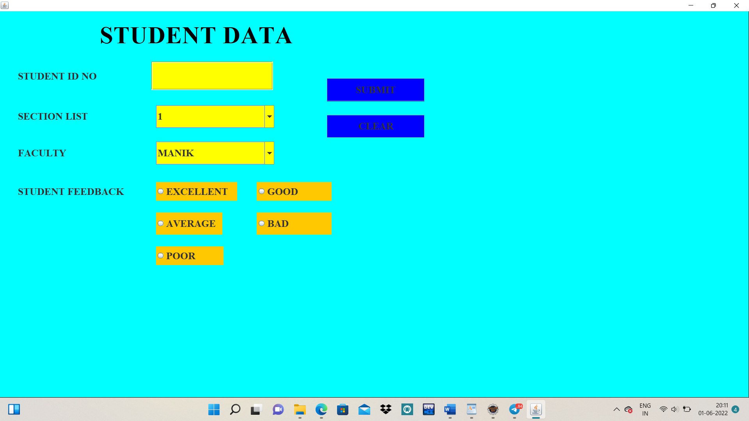

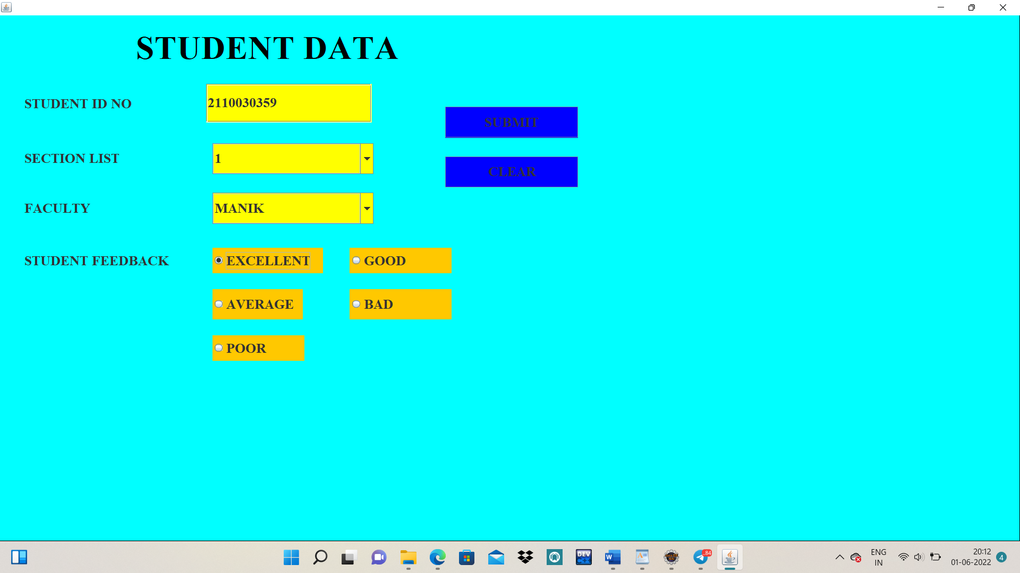

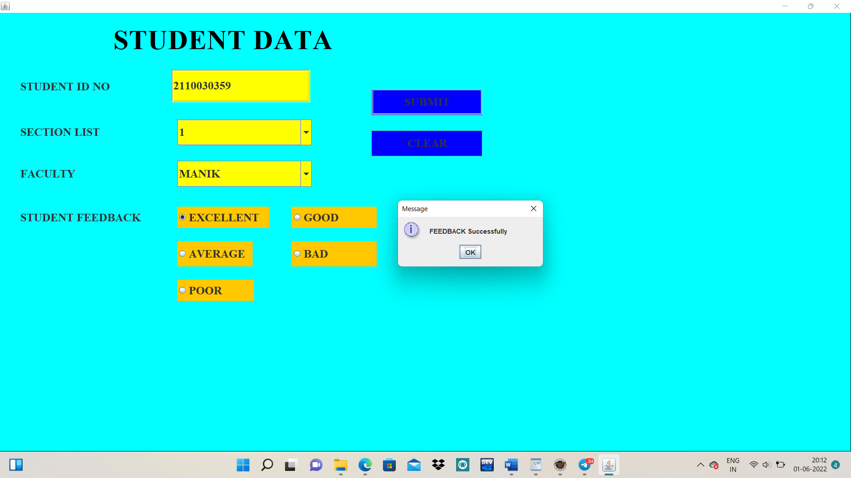

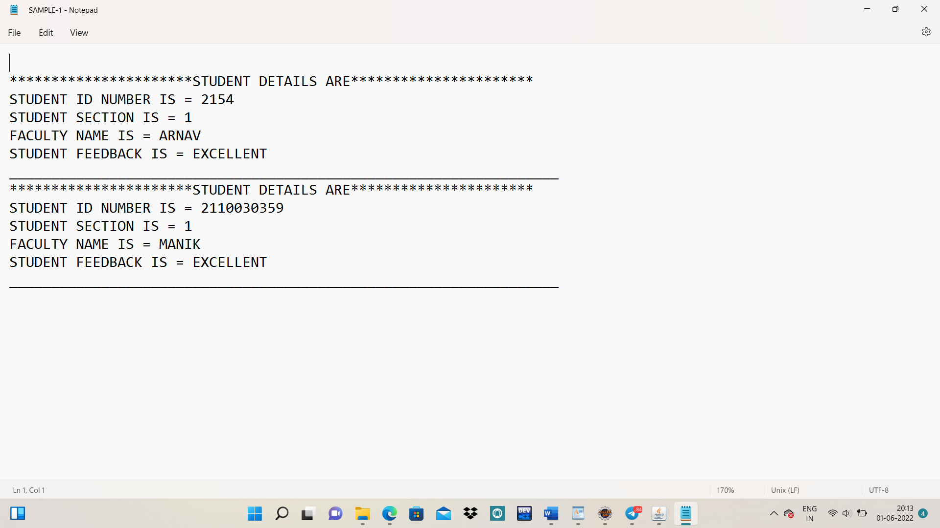

**CONCLUSION**

**& Future Work**

The main objective of this project is to create a GUI application for the student feedback form.

In this project, we have created an application and we have understood the GUI clearly. By creating this application, the customers feel very at ease communicating. The Principal of Delhi Public School will get to know his faculty’s knowledge of their respective subjects through the student feedback form.

Finally, we have created this application. We have learned about Graphics User Interfaces.

**-------THE END-------**